How To Update HostName and configure AD Authentication in RHEL 7

1. **Launch this AMI from AWS: Red Hat Enterprise Linux 7.2 (HVM), SSD Volume Type** - ami-2051294a
2. Login to the server as ec2-user and switch to root using the command sudo su
3. vi /etc/sysconfig/network  
     
   Add the HOSTNAME parameter and enter the hostname in the form of <yourchoice>.corecompete.com.

For Example:

HOSTNAME=meta3.corecompete.com

1. vi /etc/hostname  
     
   Update the hostname in the file. For example meta3.corecompete.com
2. Run the following commands to make the above file immutable during reboot:

chattr +i /etc/sysconfig/network

chattr +i /etc/hostname

1. vi /etc/hosts  
     
   Add a line in the form of <private ip> <hostname>  
     
   For example: 172.31.27.126 meta3.corecompete.com
2. vi /etc/cloud/cloud.cfg

Add at the end of the file:

preserve_hostname: true

1. vi /etc/resolv.conf  
     
   Update the domain and the name server to the following:  
     
   The file should look like this:

# Generated by NetworkManager

search corecompete.com

nameserver 172.31.23.49

1. chattr +i /etc/resolv.conf
2. vi /etc/ssh/sshd_config

PasswordAuthentication yes

1. Reboot the server by issuing reboot command
2. On AD Server, Logon as Administrator

Go to DNS, then click on Forward Lookup Zones, right click on corecompete.com, click on new Host

Add the hostname and private ip as shown in the below snapshot:

Machine generated alternative text:
'recom ete.c... 
static 
New Host 
Name (uses parent domain name if blank): 
meta 3 
Fully qualified domain name (FQDN): 
meta3. corecompete com 
[P addr ass: 
172.31.27.1261 
D Create associated (PTR) record 
[3 Allon any authentcated user to update DNS records with the 
same owner name 

1. Now coming back to the your linux Server. Login as root

1. Run: yum -y update

1. Run: yum -y install sssd realmd krb5-workstation oddjob oddjob-mkhomedir sssd samba-common-tools

1. Run: realm join -U administrator@corecompete.com corecompete.com --verbose  
     
   You will see the following output

* Resolving: _ldap._tcp.corecompete.com

* Performing LDAP DSE lookup on: 172.31.23.49

* Successfully discovered: corecompete.com

Password for administrator@corecompete.com:

* Required files: /usr/sbin/oddjobd, /usr/libexec/oddjob/mkhomedir, /usr/sbin/sssd, /usr/bin/net

* LANG=C LOGNAME=root /usr/bin/net -s /var/cache/realmd/realmd-smb-conf.6WQDLY -U administrator@corecompete.com ads join corecompete.com

Enter administrator@corecompete.com's password:

Using short domain name -- CORECOMPETE

Joined 'META3' to dns domain 'corecompete.com'

* LANG=C LOGNAME=root /usr/bin/net -s /var/cache/realmd/realmd-smb-conf.6WQDLY -U administrator@corecompete.com ads keytab create

Enter administrator@corecompete.com's password:

* /usr/bin/systemctl enable sssd.service

Created symlink from /etc/systemd/system/multi-user.target.wants/sssd.service to /usr/lib/systemd/system/sssd.service.

* /usr/bin/systemctl restart sssd.service

* /usr/bin/sh -c /usr/sbin/authconfig --update --enablesssd --enablesssdauth --enablemkhomedir --nostart && /usr/bin/systemctl enable oddjobd.service && /usr/bin/systemctl start oddjobd.service

* Successfully enrolled machine in realm

1. vi /etc/krb5.conf

Replace the contents of krb5.conf with the contents below:

[logging]

default = [FILE:/var/log/krb5libs.log](FILE:///\\var\log\krb5libs.log)

kdc = [FILE:/var/log/krb5kdc.log](FILE:///\\var\log\krb5kdc.log)

admin_server = [FILE:/var/log/kadmind.log](FILE:///\\var\log\kadmind.log)

[libdefaults]

dns_lookup_realm = false

ticket_lifetime = 24h

renew_lifetime = 7d

forwardable = true

rdns = false

default_realm = CORECOMPETE.COM

# default_ccache_name = KEYRING:persistent:%{uid}

[realms]

# EXAMPLE.COM = {

# kdc = kerberos.example.com

# admin_server = kerberos.example.com

# }

CORECOMPETE.COM = {

}

[domain_realm]

# .example.com = EXAMPLE.COM

# example.com = EXAMPLE.COM

corecompete.com = CORECOMPETE.COM

.corecompete.com = CORECOMPETE.COM

1. vi /etc/sssd/sssd.conf

Set the following parameter to False.

use_fully_qualified_names = False

1. reboot
2. AD Integration is completed. Try to login with an AD user such as administrator. You should be able to successfully login.

/* Customization by Karthik */

vi /etc/sssd/sssd.conf

Change the fallbach home directory to from /home/%u@%d to /home/%u

fallback_homedir = /home/%u@%d

for hst in `cat /etc/gridhosts`; do scp /etc/sssd/sssd.conf $hst: /etc/sssd/sssd.conf; done

Trouble shooting :

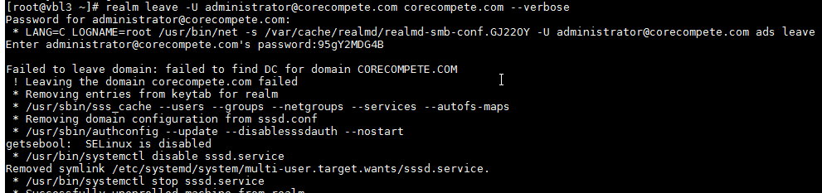

Reboot